LOOCV: Problematic due to dependence?

Write it out why it makes sense, dependence?

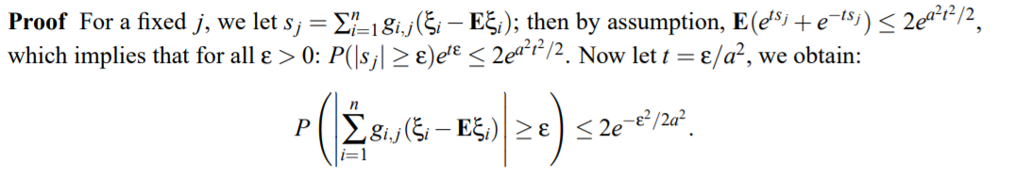

Figure out proofs, investigate lemma 8 for VAR(1) models.

The mu is not the way we want it now, it does not quantify correctly.

Focus on N different regression settings, regress X_1 on X, X_2 on X, ….

N mus, and take the max over those.